**EXPERIMENT NO. 3.3**

# AIM

To implement a class hierarchy in Java with a base class Person and derived classes Student and

Teacher using the principles of Object-Oriented Programming.

# Theory

* **Object-Oriented Programming (OOP)** organizes code into classes and objects.
* **Inheritance** allows a child class to reuse attributes and methods of a parent class.
* **Polymorphism** allows overriding methods (e.g., displayInfo()) in subclasses.
* **Java Class Hierarchy Example:**
  + Person (parent class: name, age)
  + Student (child class: rollNo, course)
  + Teacher (child class: subject, salary)

# Code (Java)

// Base class class Person {

String name; int age;

Person(String name, int age) { this.name = name;

this.age = age;

}

void displayInfo() {

System.out.println("Name: " + name + ", Age: " + age);

}

}

// Derived class: Student class Student extends Person {

String rollNo;

String course;

Student(String name, int age, String rollNo, String course) { super(name, age); // calling parent constructor this.rollNo = rollNo;

this.course = course;

}

@Override

void displayInfo() { super.displayInfo();

System.out.println("Roll No: " + rollNo + ", Course: " + course);

}

}

// Derived class: Teacher class Teacher extends Person {

String subject; double salary;

Teacher(String name, int age, String subject, double salary) { super(name, age);

this.subject = subject; this.salary = salary;

}

@Override

void displayInfo() { super.displayInfo();

System.out.println("Subject: " + subject + ", Salary: " + salary);

}

}

// Main class to run the program public class Main {

public static void main(String[] args) { System.out.println("Student Details:");

Student s1 = new Student("Rahul", 20, "S123", "Computer Science"); s1.displayInfo();

System.out.println("\nTeacher Details:");

Teacher t1 = new Teacher("Dr. Sharma", 45, "Mathematics", 75000); t1.displayInfo();

}

}

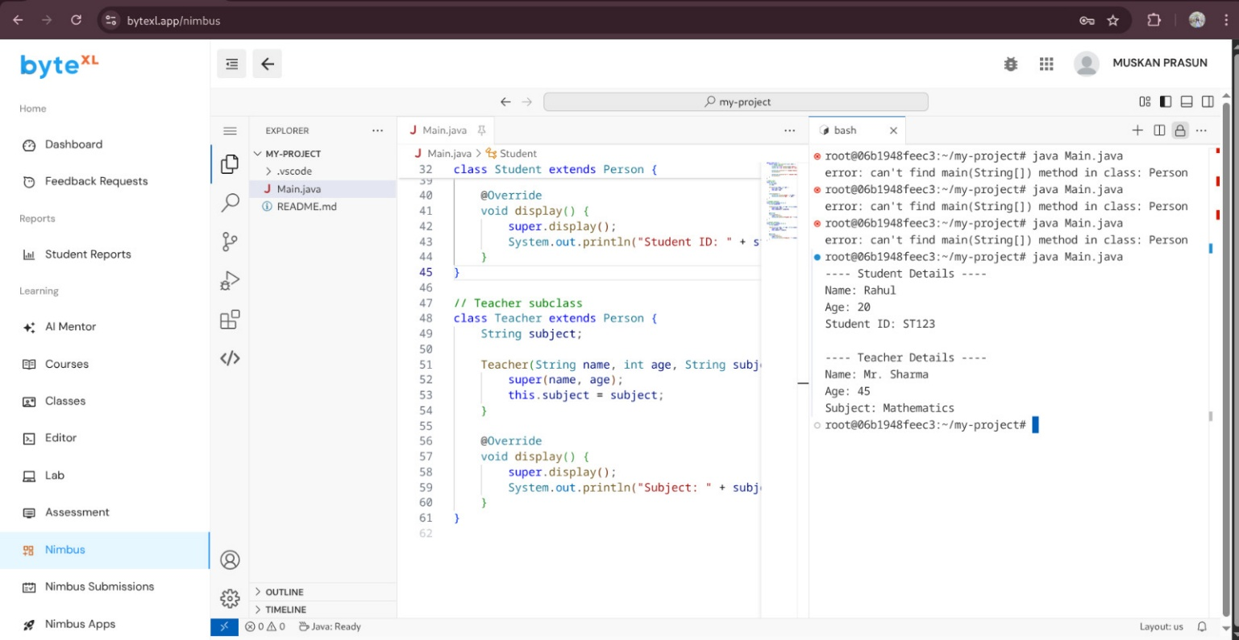

# Output

Student Details:

Name: Rahul, Age: 20

Roll No: S123, Course: Computer Science

Teacher Details:

Name: Dr. Sharma, Age: 45

Subject: Mathematics, Salary: 75000.0

# Learning Outcomes

1. Learned how to implement **class hierarchy** in Java.
2. Understood **inheritance** and **method overriding** using super.
3. Differentiated between common attributes (Person) and specialized attributes (Student, Teacher).
4. Gained practical skills for writing **clean, reusable, and modular code**.
5. Understood how class hierarchies apply to **real-world full stack projects** (users, admins, etc.).